## **Crea te a Crow’s Foot ERD for each of the following descriptions.**

*1.Each of the MegaCo Corporation’s divisions is composed of many departments. Each department has many employees assigned to it, but each employee works for only one department. Each department is managed by one employee, and each of those managers can manage only one department at a time.*

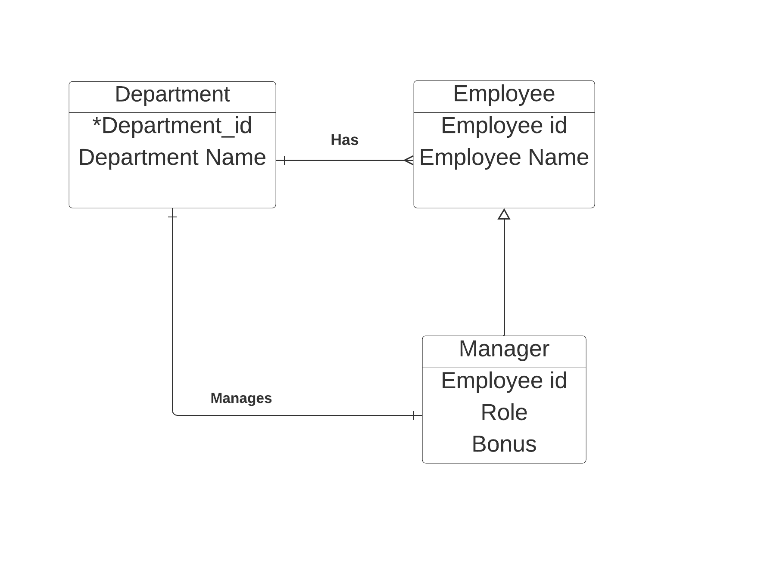

Manager entity inherits from the Employee table , taking consideration that the data unique to the manager is kept there.

Only one manager should manage one department.Their is a relationship of one-to-on across these two tables.

Departments have many employees.

Employees can only be associated with a single department.So we can employee_id should be unique throughout the table.

*2.During some period of time, a customer can download many books from BooksOnline. Each of the ebooks can be downloaded by many customers during that period of time.*

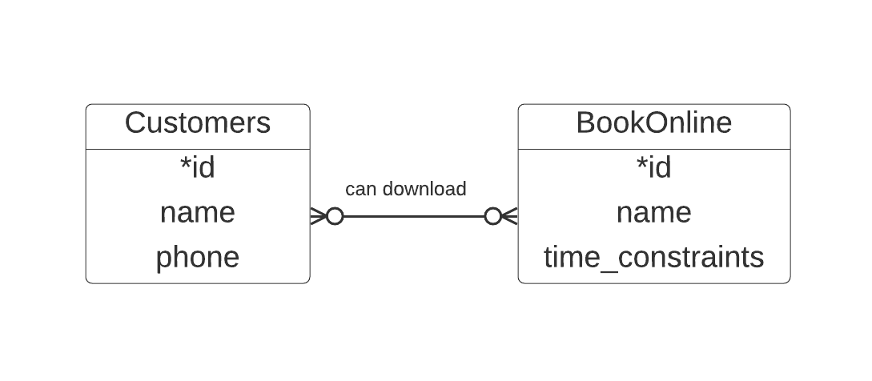

*3.An airliner can be assigned to fly many flights, but each flight is flown by only one airliner.*

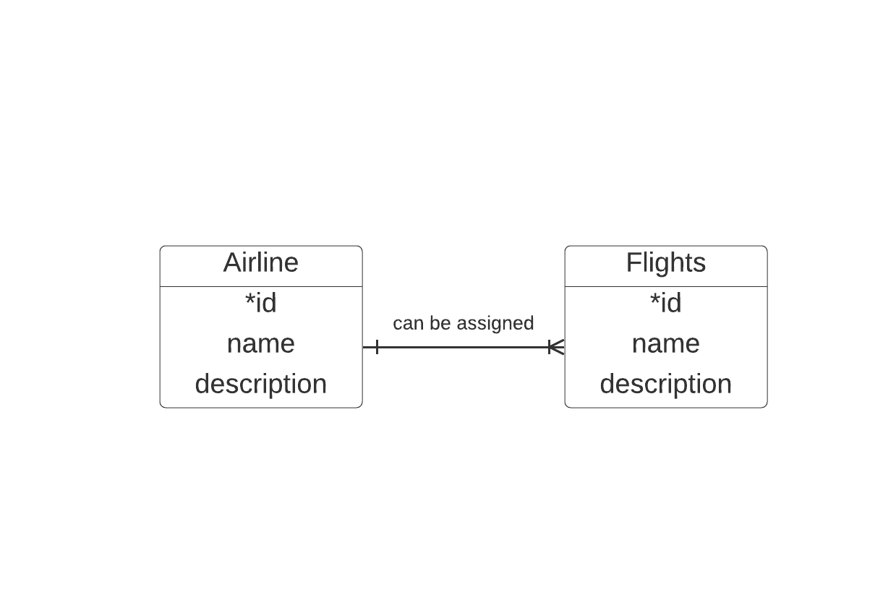

*4.The KwikTite Corporation operates many factories. Each factory is located in a region, and each region can be “home” to many of KwikTite’s factories. Each factory has many employees, but each employee is employed by only one factory.*

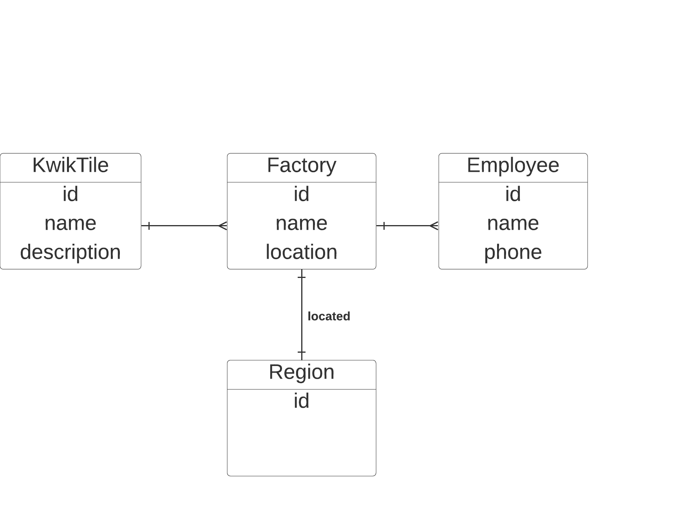

*5.An employee may have earned many degrees, and each degree may have been earned by many employees.*

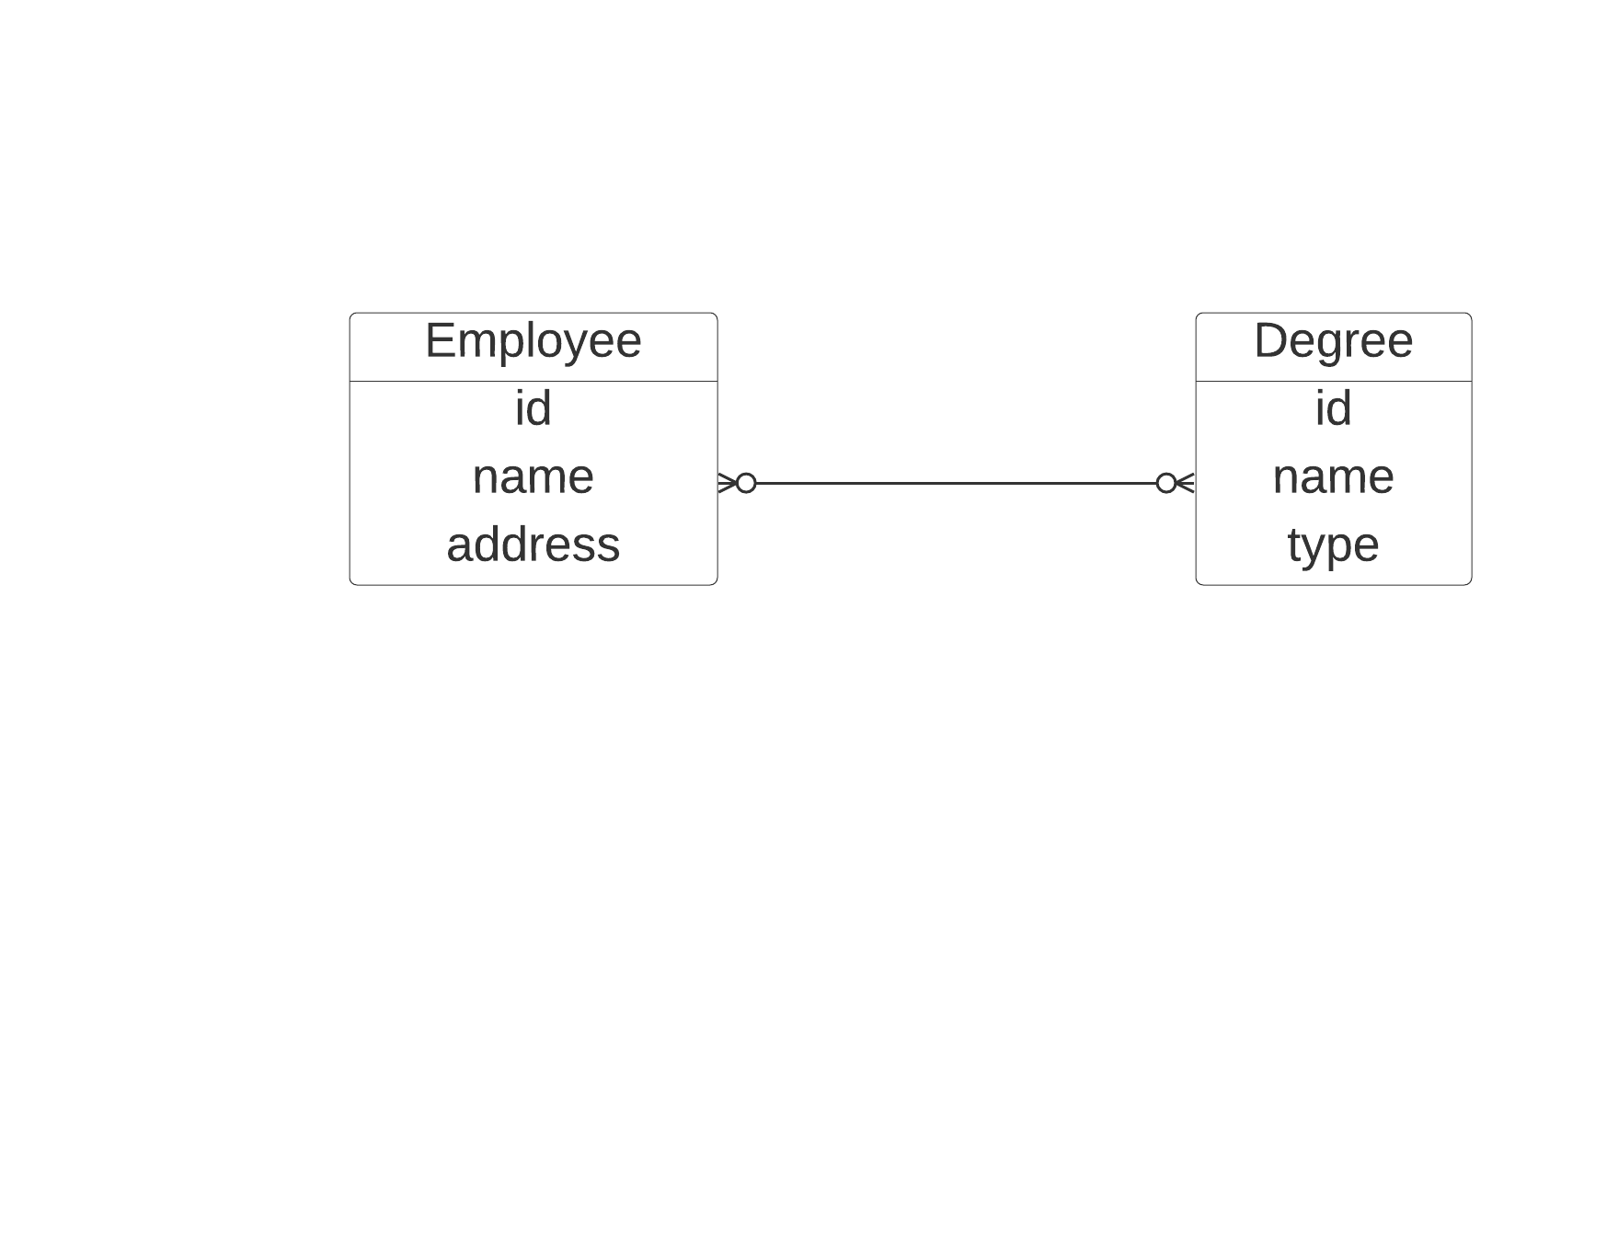

Here, Employee can have zero or many degrees whereas a Degree can belong to many employees..

*6.For a company with the following business rules*

* + - *Each sales representative writes many invoices.*
    - *Each invoice is written by one sales representative.*
    - *Each sales representative is assigned to one department.*
    - *Each department has many sales representatives.*
    - *Each customer can generate many invoices.*
    - *Each invoice is generated by one customer.*

